RESTAURANT MANAGER POS

CUSTOMIZED DISCOUNT MODULE FOR

SENIOR CITIZEN, DIPLOMAT & PWD

USER’S MANUAL

The following should be done AFTER the original bill is printed as well as acknowledged by the guests.

1. 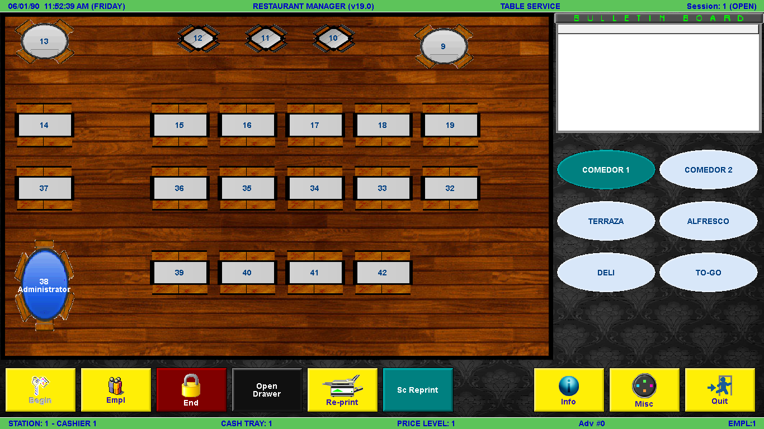At the Table Selection Screen, select one table that is to be applied with Senior/Diplomat/PWD Discount.
2. At the Order Entry Screen, press the button of the discount you want to apply. This will change the current revenue center to the respective revenue center based on the discount.

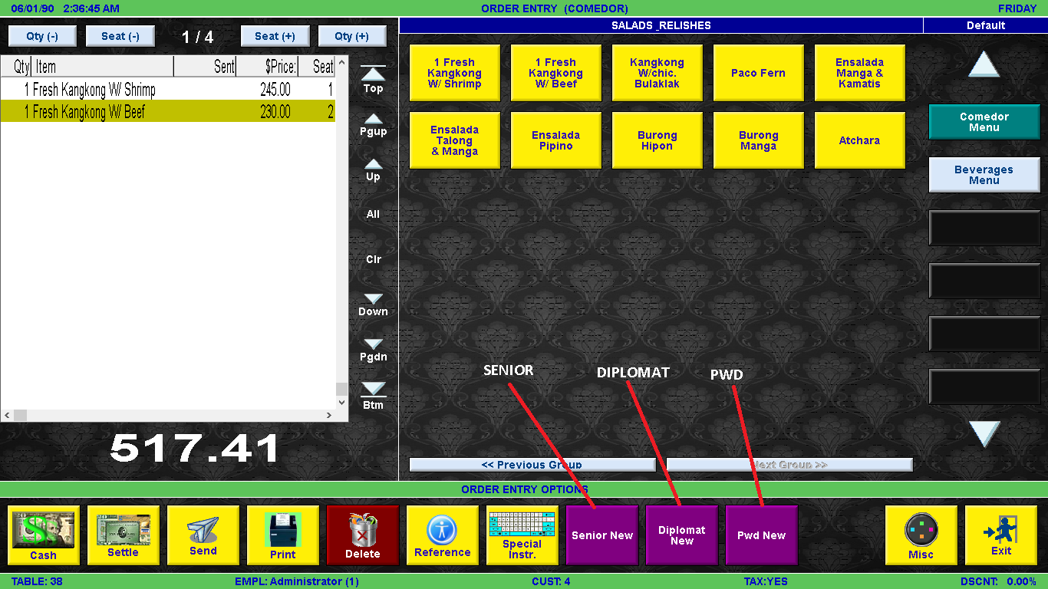

1. 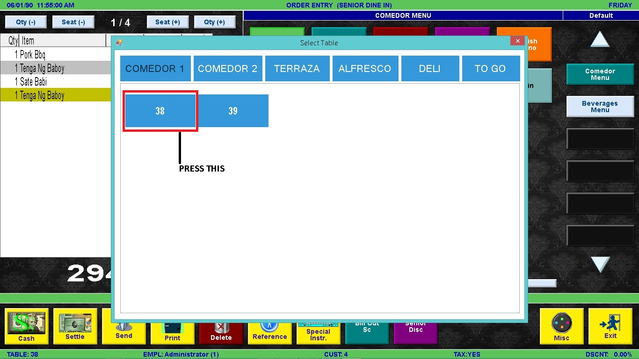The pop out window is the Customized Senior Module. Select the table group and table number you wish to apply senior citizen discount.
2. 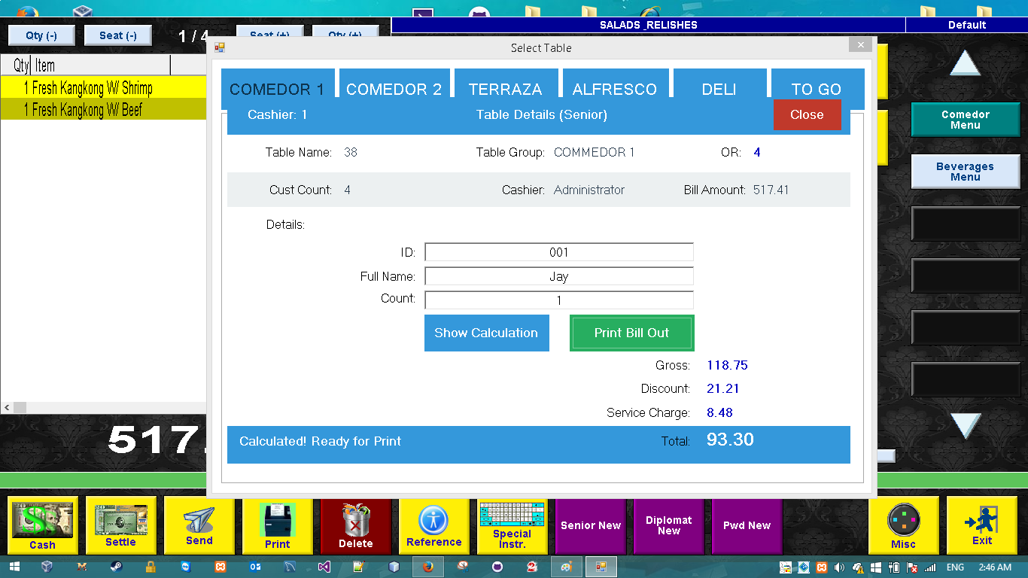The next screen is the customer detail entry screen. Encode the ID, Name and number of Guest on the textboxes provided.
3. Ones the data is encoded, press Show Calculation to see the discount then Print Bill Out to print the new bill out.

Below is the sample Bill Out printed by the new module:

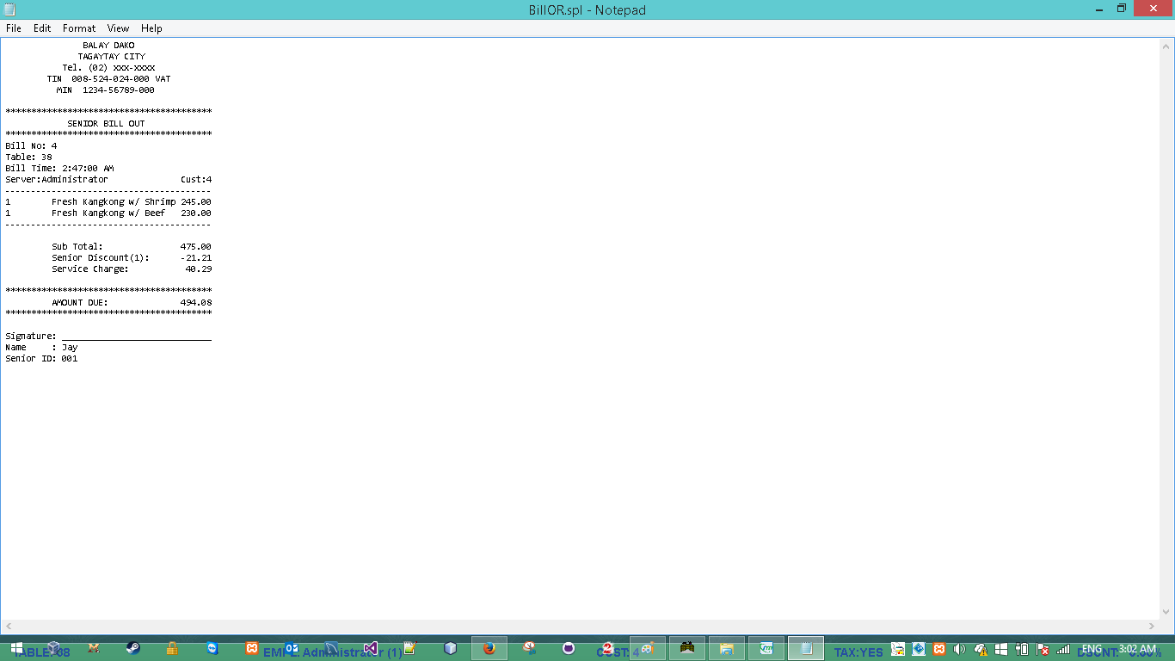

1. Once the bill out is signed/confirmed by the guest, the cashier may know press the MISC button and choose the respective discount to be applied. The cashier must MANUALLY encode the DISCOUNT amount calculated.

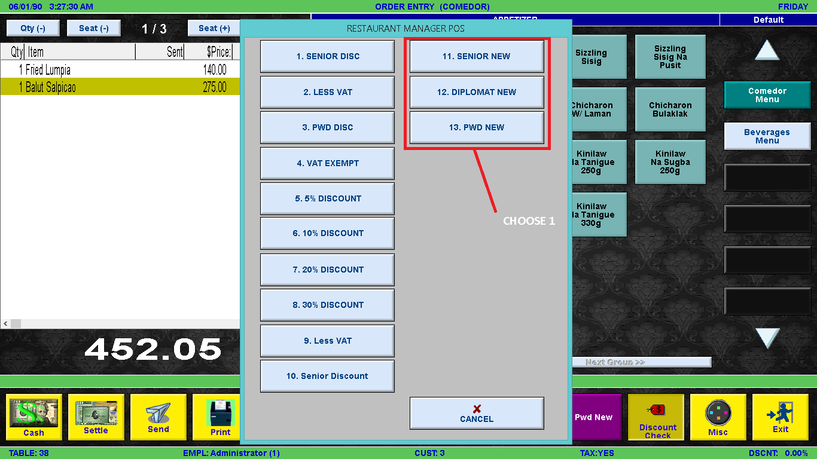

1. 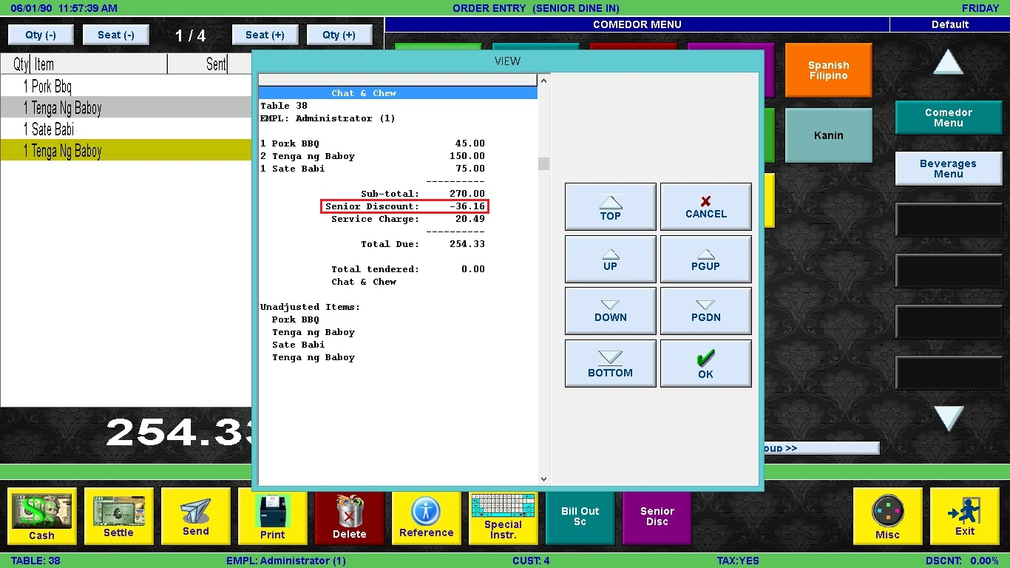Once the DISCOUNT is encoded, the data is now inside the POS database.
2. Finally, the bill is now ready for settlement. Pressing the Settle button will bring you to the Settlement Screen.

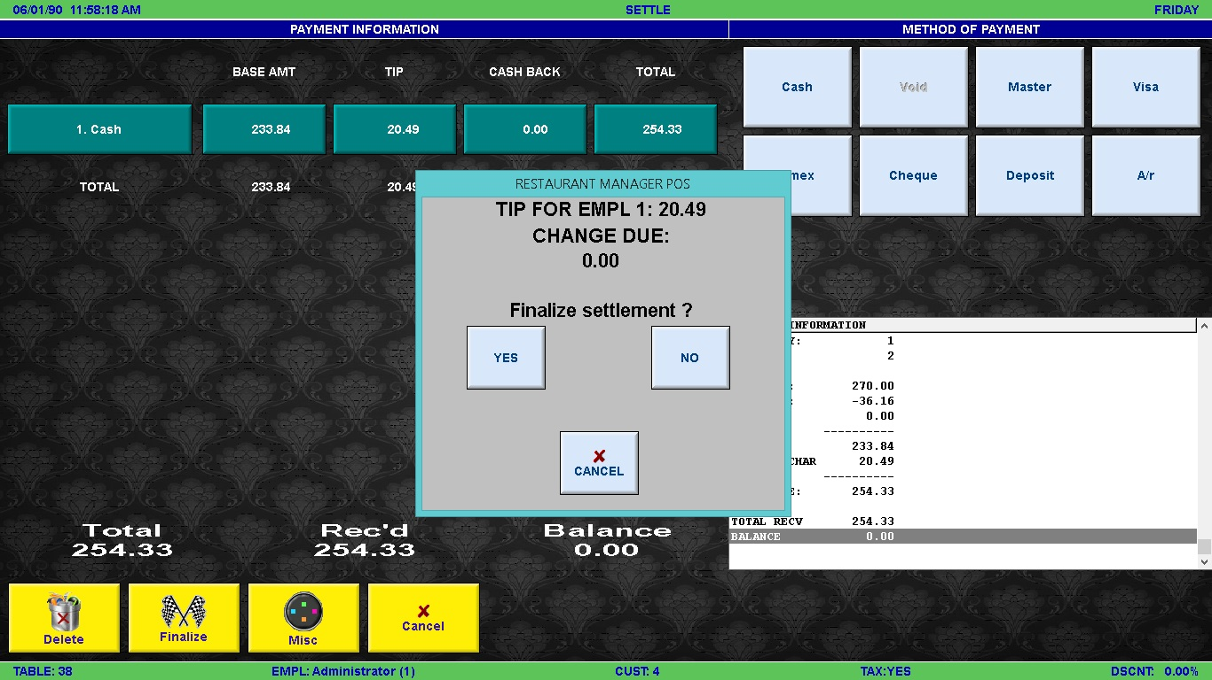

1. 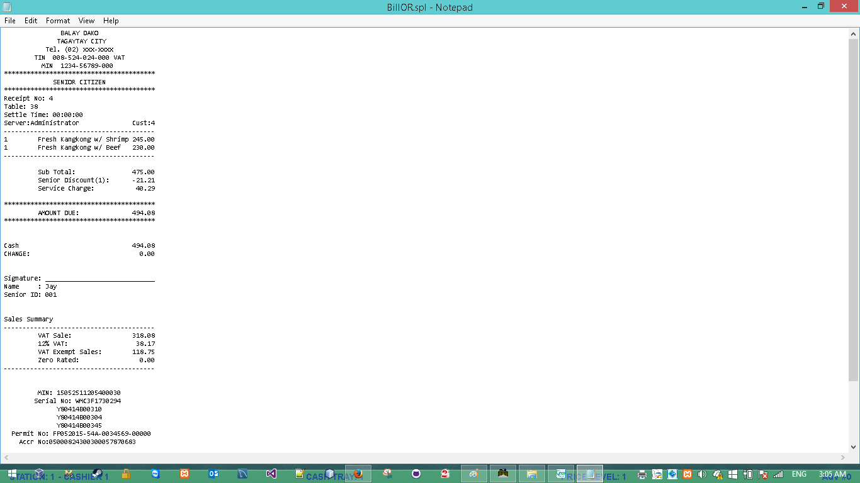Ones the table is settled, it’ll print a receipt as illustrated below: